<https://www.foodblog/stephanie/#1.com/>

# Enjoy a DELICIOUS weekend

Posted by Stephanie, October 8th, 2022, 16:30

#Shanghai #food #weekend #drinks

Good morning! (Though it’s not morning anymore huh?) The National Day 7-day-holiday just past and we were back to school :( WHAT A PITY!!! Have you tried delicious food these days? I DO and I wanna share them with you!

Imagine what you feel if you are enjoying a long holiday but have no idea which restaurant to choose? That’s a problem that I’ve met before. BUT I found 3 awesome food and drink spots that lightens up my day!

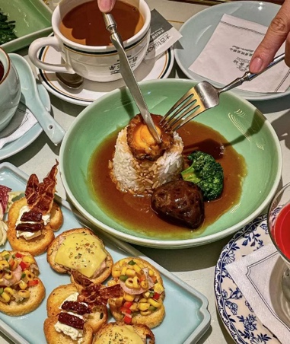

The 1st one is called *HONG KONG OLD MELODY.* The restaurant offers Cantonese cuisine, more or less like a combination between Chinese and Western food. The restaurant have light music and dim light, producing a peaceful atmosphere. The *abalone bibimbap* (rice mixed with abalone) is really tasty and if you order that one, remember to eat it before it gets cold so that you can have the best taste of it! The *Tapas Toast* also worth a try! It really has a special taste and it has 3 different varieties: bacon cheese, shrimp corn and cheese ham. BTW, another dessert that I highly recommend is the *strawberry milk jelly,* which is also very famous and popular.

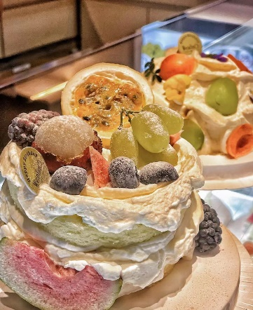The 2nd one is a dessert shop called *WenTinG.* The pastries there are magnificent. Their highly colorful looks make them look like works of ART, and they also have white peach flesh in the cakes. Though it’s not so sweet, a offers customers a fresh and cool taste that is rarely seen elsewhere. The shop also provides half-sugar cakes which are pretty healthy! Especially friendly to people who needs to lose weight, but at the same time craves delicious food. As it is shown in the picture, there are many varieties of fruit littered on the cake’s surface. Personally, I prefer the passion fruit taste cake，which also contains a LARGE amount of passion fruit jam.

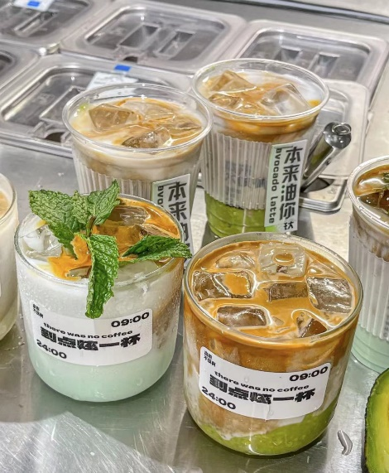Finally, I would like to recommend you a coffee shop，which is christened with interesting name called-*There was no coffee.* The name means that there used to be no coffee, but now there is, since people like the taste of it. The coffee shop also offers free cute glass bobo cups (like the one in the picture). I highly recommend the one called the mint milk coffee with both coconut milk and mint in it, and provides a cool feeling at first taste. It’s extremely suitable to have in the hot summer. I myself successfully survived under the baking sun whilst drinking the coffee!

That’s all for today’s blog! If you like it, SUBSCRIBE and SUPPORT me on twitter, Ins or WeChat 👇 ! Thx!



Stephanie_Yao Stephanie_ysn YSN

**Comment (2)**

#1 October 8th, 2022, 19:31 Bite de dust:

I’ve never heard about any of these places before. Perhaps I should consider visiting these places someday.

Replies: October 9th, 2022, 7:29 Stephanie Yao

Well, I highly recommend you having a full weekend trying these delicious foods! You shouldn’t miss any of these since every one is GOOD!

#2 October 9th, 2022, 9:27 Norman:

Thanks for your sharing and that’s pretty useful for me to have some good meals when I am having my work trip in Shanghai several days later.